Word ________________

Denotation Connotation

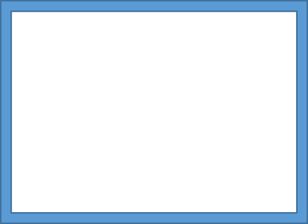

Word ________________

Denotation Connotation



Word ________________

Denotation Connotation

